Jean-Pierre Bondurant

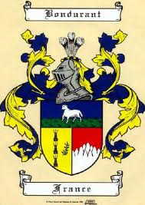

18 July, 1677 - Birth
Jean Pierre Bondurant was born on July 18, 1677, in Génolhac, France, to Gabrielle Barjon, age 34, and Jean Pierre Bondurant, age 41.
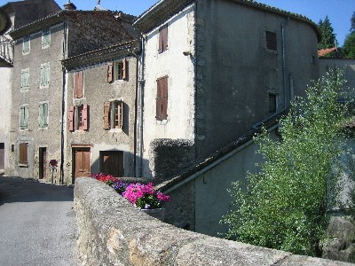
Figure 1 Génolhac, France
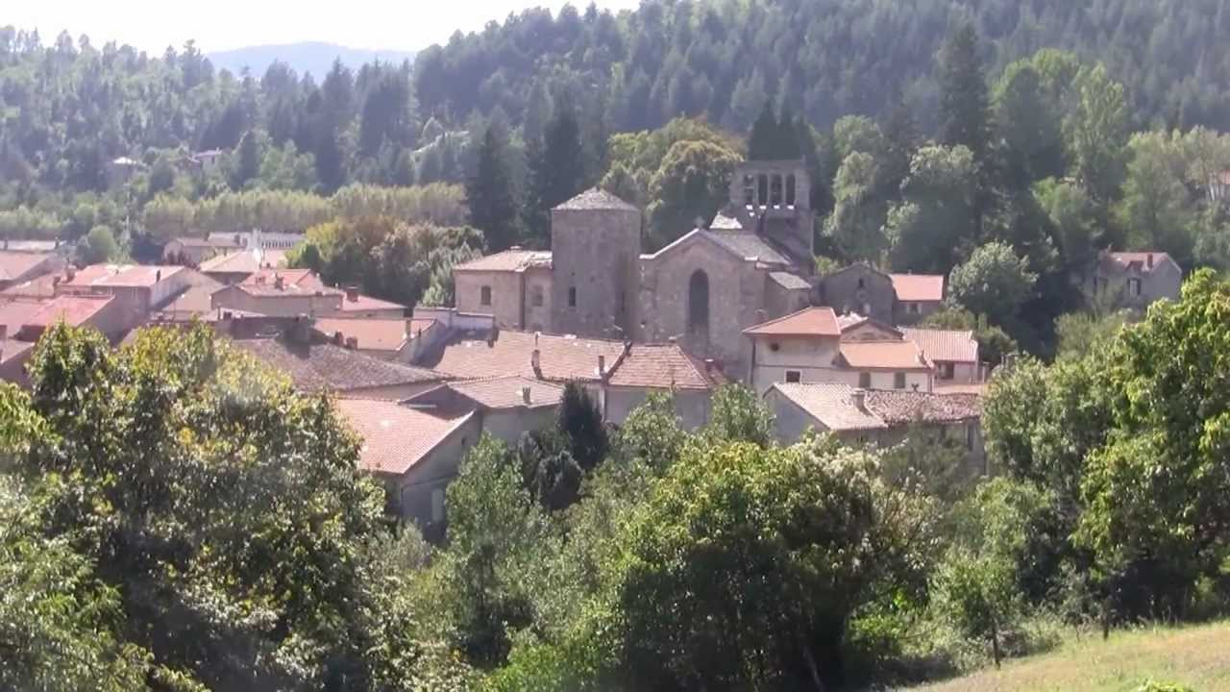
Figure 2 Village of Génolhac today
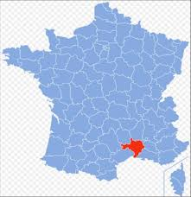
Figure 3 Location of Génolhac in France
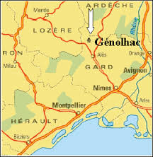
Figure 4 Génolhac is a small town in the mountains of Languedoc, approximately 50 miles north of Arles.

1677 –A Time of Religious Persecution in France under King Louis XIV
Catholic King Louis XIV persecuted the Huguenots, deeming their Protestant Reformation beliefs a threat to his authority. Many men and women were imprisoned and their children kidnapped or forcibly removed and sent to Catholic orphanages.
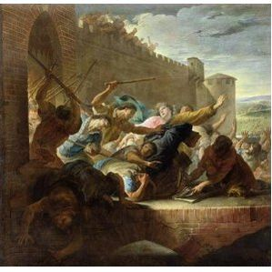
Figure 5 Persecution of the Huguenots

Circa 1678 – Baptism
Although there was widespread persecution of Protestants in France, Jean Pierre was baptized in the Protestant Huguenot faith.
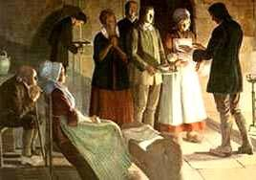

Circa 1680 – Bondurant Family Lands
The Bondurant family held extensive lands inherited from Jean Pierre's grandmother, Françoise de Joyeuse, including several mills. Françoise de Joyeuse was heiress of Cougoussac. Remains of the castle of Cougoussac stand today.

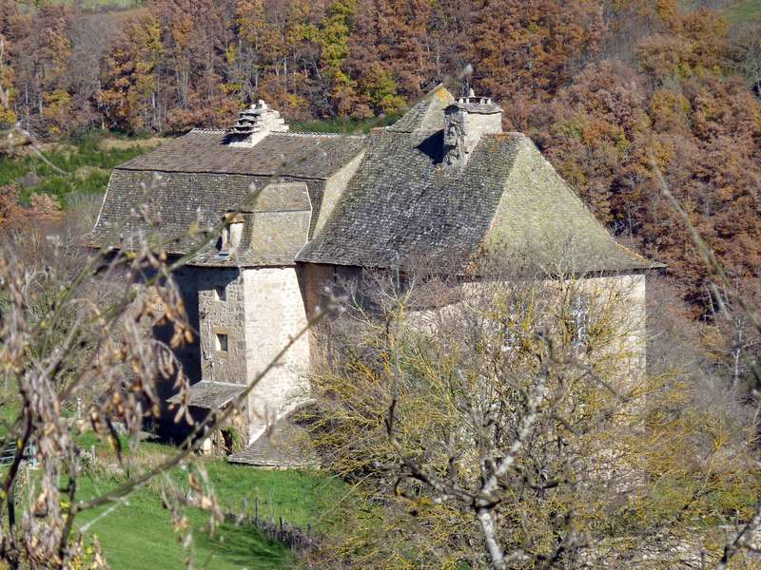
Figure 6 Château de Cougoussac

1685 - Forced to Renounce Protestant faith
The Edict of Nantes (1598) had granted the Huguenots the right to practice their religion without persecution from the state. In 1685 Louis XIV revoked the edict, believing the Protestant faith to be a threat to his authority since it encouraged following one’s own conscience rather than adhering to Catholicism, the state religion over which he had much influence. Full-scale persecution of Protestants ensued. One of Jean-Pierre’s uncles was eventually arrested, imprisoned in a dungeon for two years, and forced to labor as a galley slave on Louis XIV’s ships. He died of the harsh treatment. Many families were torn apart, parents imprisoned and their children sent to Catholic orphanages. Jean-Pierre’s maternal uncle, a Protestant pastor, led a group of his fellow Huguenots to safety in Switzerland, where they could practice their faith.
In 1685 Jean Pierre's parents, his grandfather and step-grandmother were forced to renounce their Huguenot faith. At age seven Jean Pierre was rebaptized a Catholic in order to preserve his right to inherit family property.
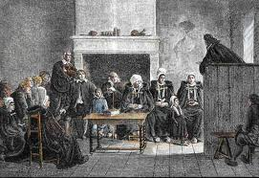

4 July 1694 - Death of Father
Jean-Pierre’s father passed away on July 4, 1694, in Génolhac, at the age of 58.

23 May, 1695 - Death of Mother
His mother Gabrielle passed away on May 23, 1695, in Génolhac, at the age of 52.

Orphaned
Orphaned, Jean Pierre was left in the guardianship of his father's cousin, André Bondurant, a Master Apothecary and mayor of Génolhac.

1696 - Apprenticed to Apothecary
At age 19, Jean-Pierre became the apprentice of André Bondurant. Jean Pierre learned enough medicine to be accounted a Doctor in the Colonies in Virginia.
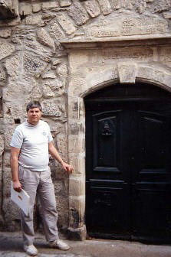
Figure 7 Doorway of apothecary shop of André and Jean-Pierre Bondurant in Génolhac, France. Descendants visited in 1993.
Antoine and Jean Pierre were apothecaries, and the caduceus over the entrance to both the house and a ground floor room apparently used as their office, served as advertisements for their business.
During the 1500s and 1600s the apothecary shop was an inn. Genolhac was located on the main highway south from Paris to the Mediterranean. A covered passage led to the town’s main street. The courtyard once was filled with wagons and horses of teamsters, bringing goods from the interior to the seaports.
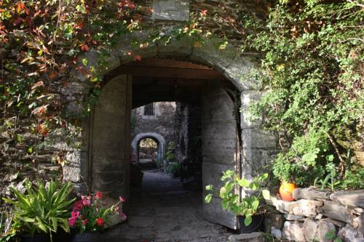
Figure 8 Typical courtyard passageway in Génolhac

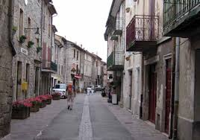
Figure 9 Main Street of Génolhac

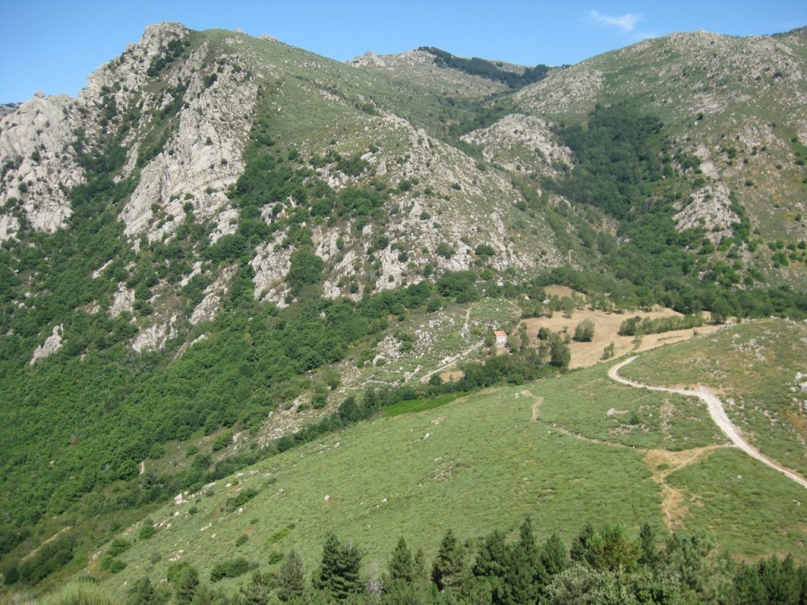
Figure 10 Génolhac Road that once connected Paris and the Mediterranean.

Sept. 1697 - Inheritance Sold
In September 1697, fearing persecution, Jean-Pierre sold his property, with Andre's consent. The mills at l'Aribal and Calquières, inherited from his parents, were sold. Jean Pierre escaped to Switzerland, where he joined his maternal uncle, Guillaume Barjon, pastor of the Huguenot refugee church there. On October 3, 1697, Jean Pierre recanted the Catholic faith.
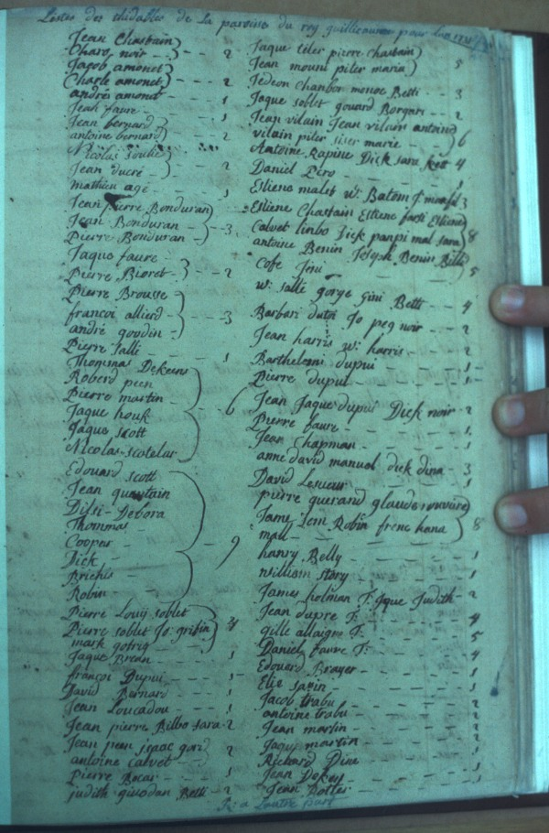
Figure 11 Switzerland, 1697 - List of members of Huguenot church of pastor Guillaume Barjon, Jean-Pierre’s uncle. Refugees escaped persecution in France and fled to Switzerland, then to Germany, England, and Virginia.

1697-98 Refugee in Switzerland
Because Jean Pierre had left France with money from the sale of his mills, he did not appear on the Swiss charity records as did most refugee Huguenots. Being financially independent shielded him from scrutiny and later enabled him to buy land in Virginia.

1699 Huguenot Immigration to Germany, England and Virginia
Soon after the revocation of the Edict of Nantes, King William and Queen Mary ascended to the throne of England. They offered the persecuted Huguenots the privilege of settling in Virginia. Jean Pierre joined the second group of refugees given passage. The Huguenot group left Switzerland together and traveled first to what is now Germany, then on to England. In 1699, in the company of Pastor Barjon and other refugees, he went to Karlshafen, Germany.

20 September, 1700 - Arrival in Virginia
There is no record of Jean Pierre's travel from Karlshafen to England, but he was among Huguenot refugees arriving at the mouth of the James River in Virginia on 20 September 1700 aboard the ship "Ye Peter and Anthony", which had sailed from England. Jean-Pierre was 23.
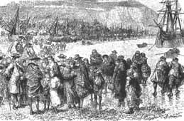

October 1700 - Joined Huguenot Refugee Settlement in Virginia
The immigrants were taken up the James River in smaller boats as far as the shoals (present day Richmond.) They went overland to Manakin Town, where they joined other Huguenot settlers.

Practices Medicine in Virginia
Jean Pierre stayed with the colony until 1701 and then began practicing medicine in Henrico County, Virginia.

1705 - Granted Citizenship
In 1704, the Huguenot men petitioned to become citizens of the colony. By an act passed in 1705 they were granted citizenship by the Governor and House of Burgesses. Jean Pierre was 25.

1706 - Purchases Land in Virginia
Jean Pierre obtained 200 acres of land on Old Town Creek, near present Matoaca, across the Appomattox River from Petersburg, and 400 acres on the south side of the James River in Henrico County.

1708 – Marriage
Jean Pierre Bondurant married Rhoda Ann Faure (?) in Goochland, Virginia, in 1708 when he was 31 years old. (Unknown if he was married more than once and which children belong to each wife. A wife Ann, the mother of his son Peter, is mentioned in his will. Many researchers thought this was Ann Faure but this appears incorrect. She may have been Ann Tanner.)

1720 - Birth of Son
His son Joseph Augustine was born in 1720 in Virginia.

5 September, 1735 - Death
Jean Pierre Bondurant died on September 5, 1734, in Goochland, Virginia, when he was 57 years old.

Burial
A plaque erected by his descendants reads: To the glory of God and in memory of Jean Pierre Bondurant and his wife Ann. Born in Génolhac, France 18 July 1677, Jean Pierre (John Peter) Bondurant escaped to Switzerland in 1697, and reached Jamestown with other Huguenots in 1700. Trained as an apothecary, he practiced medicine in Virginia where he married Ann. Members of King William Parish. He died near Manakin 1734/35. Their five children were John, Peter, Joseph, Ann and Frances.
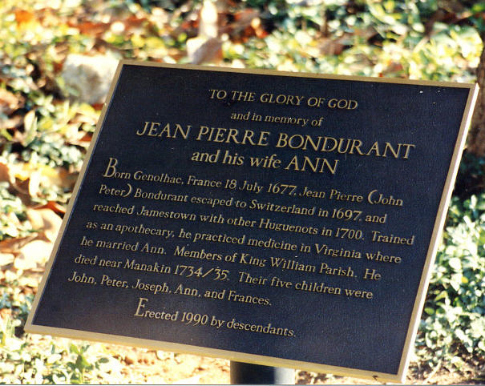

1897 - Life of Jean Pierre Described in Archives of Auburn University
Alexander Bondurant Collection in archives of Auburn University: In his “History and Reminiscences”, Alexander, descendant of Jean Pierre, describes the Huguenot's immigration to Virginia. (Jean-Pierre Bondurant was Alexander’s great-great grandfather.)

Immigration as Recorded by Alexander Bondurant:
"My paternal ancestors were French Hugenots, who fled from France during the religious persecution of that sect, in the reign of Louis fourteenth. Being of chivalorous race, believing in ‘sensing God according to the dictates of their own conscience’, they abandoned their homes & property and took refuge in the new settled Country, Virginia, in North-America, taking up land and making their home on the beautiful banks of James-River at Manakintown, a few miles above the present City of Richmond.”


